**UID EXP-1**

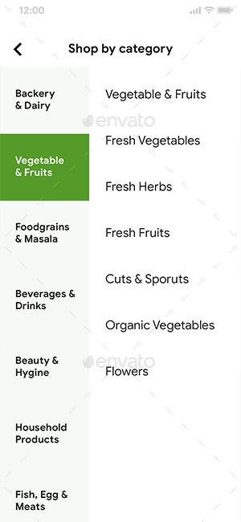

This design doesn’t look appealing because all the categories are tightly packed, which might make it difficult for users to find the right product quickly and efficiently. Therefore, I’ve made some changes to the design. Now, all food items have a product image, and they’re highly categorized based on their type.

I’ve also created an exclusive offers slide to entice users to buy more products than they usually would. 